**Encontro Motard com os Núcleos Regionais Norte e Centro**

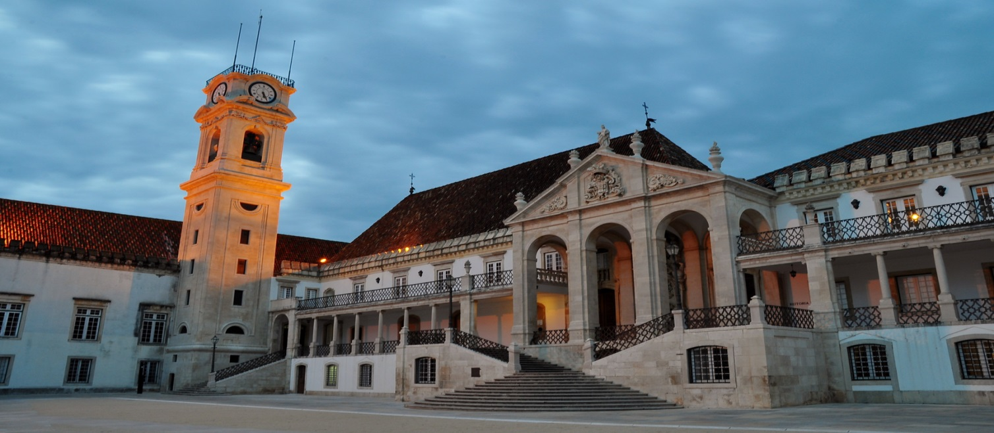

|  |  |
| --- | --- |
| **Sócios** | **Não Sócios** |
| **15,00€** | **30,00€** |

A **Secção de Motociclismo do GDC Fidelidade** organiza no dia **30 de junho** (sábado),um encontro motard com os Núcleos Regionais Norte e Centro.

O ponto de encontro será pelas **10h00,** junto à torre do relógio na Figueira da Foz para realizarmos um breve passeio pela cidade. Em seguida, iremos visitar uma exploração de aquacultura.

Terminada a visita, seguiremos com destino a Coimbra, atravessando os campos de arroz do Baixo Mondego com passagem por Montemor-o-Velho.

Ao A**lmoço** será servido leitão no Mototurismo do Centro.

Na parte da tarde daremos início à visita pela Universidade de Coimbra (Biblioteca Joanina, Sala dos Capelos e subida à Torre da Universidade).

Os colegas interessados em participar deverão contactar, até dia **27 de junho**, o colega João Camilo para o email [jcamilo.pereira@gmail.com](mailto:jcamilo.pereira@gmail.com) ou utilizar os seguintes contactos: **João Camilo** (Lisboa) – 935874545; **Miguel Lemos** (Centro) – 937232801; **Licinio Malafaia** (Norte) - 936859292

|  |  |  |  |  |  |  |  |  |  |  |  |  |  |  |  |  |  |  |  |  |  |  |  |  |  |  |  |  |  |  |  |  |  |  |  |  |  |  |  |  |  |  |  |  |  |  |  |  |  |  |  |  |  |  |  |  |  |  |  |  |  |  |  |  |  |  |  |  |  |  |  |  |  |  |  |  |  |  |  |  |  |  |  |  |  |  |  |  |  |  |  |  |  |  |  |  |  |  |  |  |  |  |  |  |  |  |  |  |  |  |  |  |  |  |  |  |  |  |  |  |  |  |  |  |  |  |  |  |  |  |  |
| --- | --- | --- | --- | --- | --- | --- | --- | --- | --- | --- | --- | --- | --- | --- | --- | --- | --- | --- | --- | --- | --- | --- | --- | --- | --- | --- | --- | --- | --- | --- | --- | --- | --- | --- | --- | --- | --- | --- | --- | --- | --- | --- | --- | --- | --- | --- | --- | --- | --- | --- | --- | --- | --- | --- | --- | --- | --- | --- | --- | --- | --- | --- | --- | --- | --- | --- | --- | --- | --- | --- | --- | --- | --- | --- | --- | --- | --- | --- | --- | --- | --- | --- | --- | --- | --- | --- | --- | --- | --- | --- | --- | --- | --- | --- | --- | --- | --- | --- | --- | --- | --- | --- | --- | --- | --- | --- | --- | --- | --- | --- | --- | --- | --- | --- | --- | --- | --- | --- | --- | --- | --- | --- | --- | --- | --- | --- | --- | --- | --- | --- | --- |
| **Ficha de Inscrição** | | | | | | | | | | | | | | | | | | | | | | | | | | | | | | | | | | | | | | | | | | | | | | | | | | | | | | | | | | | | | | | | | | | | | | | | | | | | | | | | | | | | | | | | | | | | | | | | | | | | | | | | | | | | | | | | | | | | | | | | | | | | | | | | | | | |
|  | |  | |  | |  |  | | |  | |  | | |  | |  | |  | | |  | |  | |  | |  | | |  | | |  |  | | |  | | |  |  | | |  | | |  | | |  | |  | | |  | | |  | |  | |  | | |  | | | |  | |  | | |  | | | |  | | | |  | |  | | | | | | | | | | |  | | | | |  |  | | | |  | | | | | | | |  | |  | | | | |  | | |  | |  | |  | | |  |  | |  | | | | |
| **Nome:** | | | | | |  | | | | | | | | | | | | | | | | | | | | | | | | | | | | | | | | | | | | | | | | | | | | | | | | | | | | | | | | | | | | | | | | | | | | | | | | | | | | | | | **Nº Sócio:** | | | | | | | | | | | | | | | | |  | | | | | | | | | | | | | | | | | | | | | | | | | | |  |  | |  | | | | | | | | | | | | | | | | | | | | | | | | | | |
|  | | | | | | | | | | | | | | | | | | |  | | |  | |  | |  | |  | | |  | | |  |  | | |  | | |  |  | | |  | | |  | | |  | |  | | |  | | |  | |  | |  | | |  | | | |  | |  | | |  | | | | |  | | |  | |  | | | | | | | | | | |  | | |  | | |  | | | |  | | | | | | | |  | |  | | | | |  | | |  | |  | |  | | |  |  | |  | | | | | | | | | | | | | | | | | | | | | | | | | | | | | | | |
| **Data Nasc:** | | | | | | | | | |  | | | | | | | | | | | | | | | | | | | | | | | | | **NIF:** | | | | | | | | | | | | | |  | | | | | | | | | | | | | | | | | | | | | | | | | | | | | | | | | | | |  | | | | | | | | | | | | | |  | | |  | | | |  | | | | | | | |  | |  | | | | |  | | |  | |  | |  | | |  |  | |  | | | | | | | | | | | | | | | | | | | | | | | | | | | | | | | |
|  | |  | |  | |  |  | | |  | |  | | |  | |  | |  | | |  | |  | |  | |  | | |  | | |  |  | | |  | | |  |  | | |  | | |  | | |  | |  | | |  | | |  | |  | |  | | |  | | | |  | |  | | |  | | | | |  | | |  | |  | | | | | | | | | | |  | | |  | | |  | | | |  | | | | | | | |  | |  | | | | |  | | |  | |  | |  | | |  |  | |  | | | | | | | | | | | | | | | | | | | | | | | | | | | | | | | |
| **Outros Participantes:** | | | | | | | | | | | | | | | | | | | | | | | | | | | | | | | | | |  |  | | |  | | |  |  | | |  | | |  | | |  | |  | | |  | | |  | |  | |  | | |  | | | |  | |  | | |  | | | | |  | | |  | |  | | | | | | | | | | |  | | |  | | |  | | | |  | | | | | | | |  | |  | | | | |  | | |  | |  | |  | | |  |  | |  | | | | | | | | | | | | | | | | | | | | | | | | | | | | | | | |
|  | | | | | | | | | | | | | | | | | | | | | | | | | | | | | | | | | | | | | | | | | | | | | | | | | | | | | | | | | | | | | **Data Nasc:** | | | | | | | | | | | | | | | |  | | | | | | | | | | | | | | | | | **Sócio Nº:** | | | | | | | | | | | | | | | | | |  | | | | | | | | | | | | | | | **Não** | | | |  |  | |  | | | | | | | | | | | | | | | | | | | | | | | | | | | | | | | |
|  | | | | | | | | | | | | | | | | | | | | | | | | | | | | | | | | | | | | | | | | | | | | | | | | | | | | | | | | | | | | | | | | | | | | | | | | | | | | | | | | | | |  | |  | | | | | | | | | | |  | | |  | | |  | | | |  | | | | | | | |  | |  | | | | |  | | |  | |  | |  | | |  |  | |  | | | | | | | | | | | | | | | | | | | | | | | | | | | | | | | |
|  | | | | | | | | | | | | | | | | | | | | | | | | | | | | | | | | | | | | | | | | | | | | | | | | | | | | | | | | | | | | | **Data Nasc:** | | | | | | | | | | | | | | | |  | | | | | | | | | | | | | | | | | **Sócio Nº:** | | | | | | | | | | | | | | | | | |  | | | | | | | | | | | | | | | **Não** | | | |  |  | |  | | | | | | | | | | | | | | | | | | | | | | | | | | | | | | | |
|  | | | | | | | | | | | | | | | | | | | | | | | | | | | | | | | | | | | | | | | | | | | | | | | | | | | | | | | | | | | | | | | | | | | | | | | | | | | | | | | | | | |  | |  | | | | | | | | | | |  | | |  | | |  | | | |  | | | | | | | |  | |  | | | | |  | | |  | |  | |  | | |  |  | |  | | | | | | | | | | | | | | | | | | | | | | | | | | | | | | | |
| **Email:** | | | | | |  | | | | | | | | | | | | | | | | | | | | | | | | | | | | | | | | | | | | | | | | | | | | | | | | | | | | | | | | | | |  | | | | | | | | | | | | | | | | | | | | | | | | | | | |  | | | |  | | | | | | |  | | | |  | | | | | |  | | | | |  | | | | | |
|  | | | | | | | | |  | | | |  | | |  | | | |  | | |  | | |  | | |  | | |  | | | | |  | | |  | | |  | | |  | | | |  | | | |  | | |  | | |  | | | |  | | | |  | | |  | | |  | | | |  | | | |  | | | |  | |  | |  | |  | | |  | | | | |  | | | |  | | | |  | | |  | | | | | | |  | | | |  | | |  | | | | | | | | | | |  | |  | | | | |  | |  | | |  | |  | |  | |  | |  | |  | | |  | |  | |  |
| **Pagamento:** | | | | | | | | | | **Venc.** | | | | | | | | | | | | | | | |  | | | **Numerário** | | | | | | | | | | | | | | | | | | | | | | | | |  | | | **T. B. – 003521790001079833036** | | | | | | | | | | | | | | | | | | | | | | | | | | | | | | | | | | | | | | | | | | | | | | | | | | | | | |  | |  | | | | | | | | | | | | | | | | | | | | | | | | | | | |  | | |  | |
|  | | |  | |  | | |  | | |  | | |  | | | |  | | |  | | | |  | |  | | |  | | |  | | |  | | |  | | | | |  | | |  | | | | |  | | |  | | |  | | | |  | | |  | | | |  | | | |  | | |  | | | | |  | | | | | |  | |  | |  | |  | | | |  | | | | | |  | | | |  | | |  | | | | | | | | |  | | | |  | | | | | | | | | |  | | | |  | | |  | |  | | | | |  | |  | |  | |  | |  | |  | | |  | |  | |  | |
| **Assinatura:** | | | | | | | | | |  | | | | | | | | | | | | | | | | | | | | | | | | | | | | | | | | | | | | | | | | | | | | | | | | | | | | | | | | | **Telemóvel:** | | | | | | | | | | | | | | | | |  | | | | | | | | | | | | | | | | | | | | | | | **Data:** | | | | | | | | | |  | | | | | | | | | | | | | | | |  | |